Mindfulness-Based Stress Reduction Group!

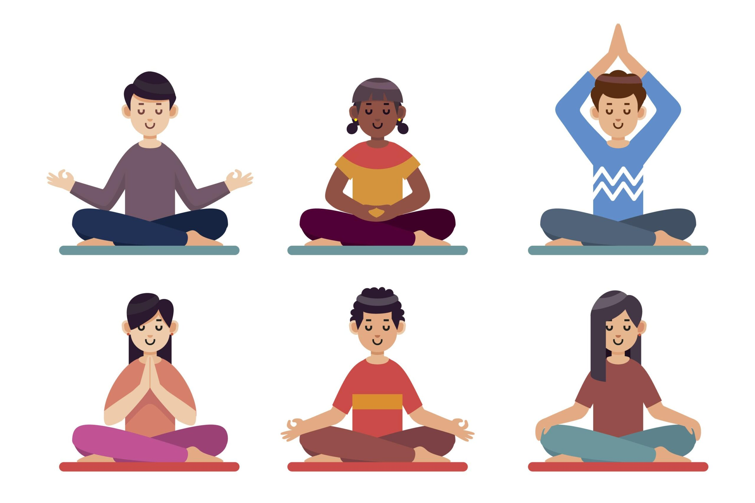

Join us Friday mornings twice a month at 10 am for a low-impact yoga, mindfulness and discussion group. All ages, abilities and experience levels welcome! This will be hosted online over web-cam (Lighthouse Center can help you to acquire and train on technology if needed, or you can participate by phone.)

If you know or someone you know might be interested, call us at (218) 624-4828 or email Jessica at JessicaM@LCFVL.org

