Join us for the
Creature Comforts Club!
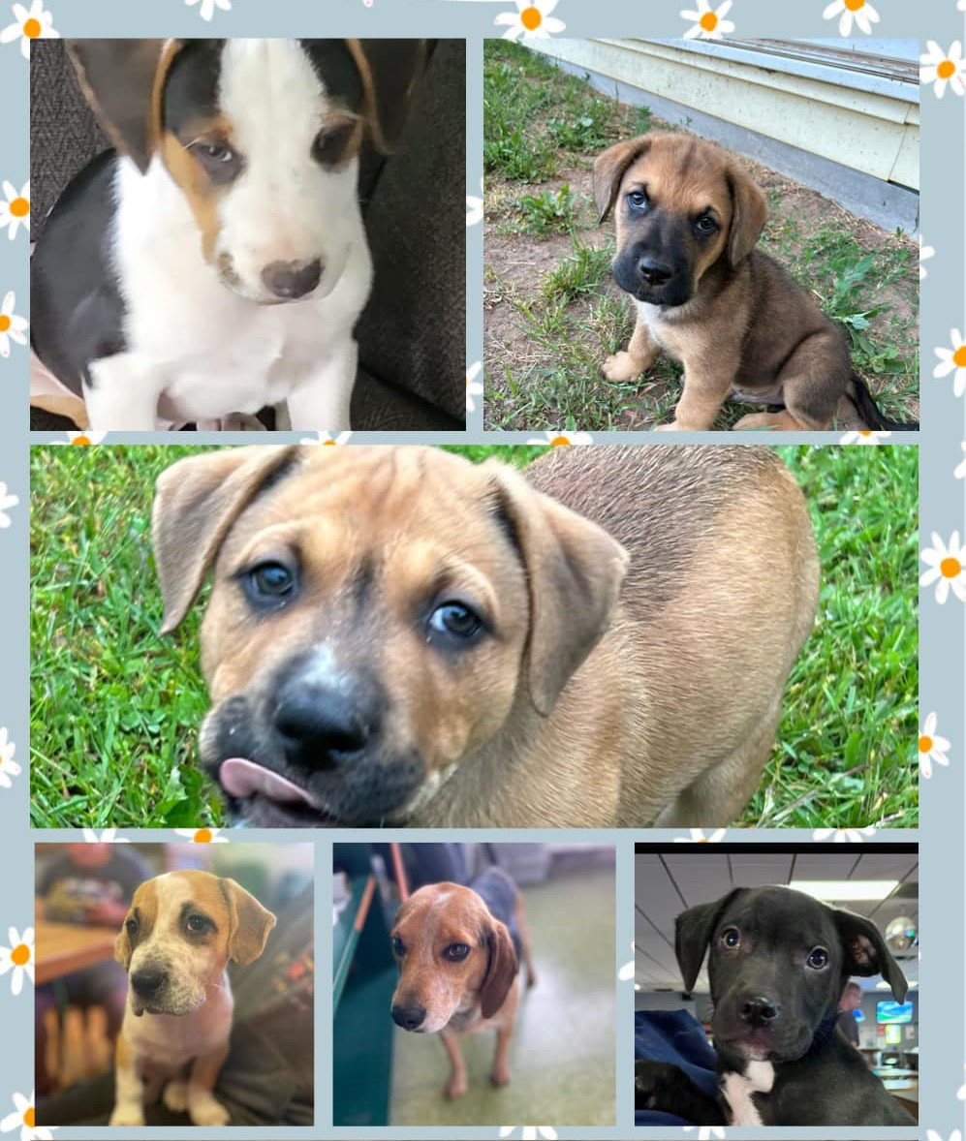

Want to play, cuddle, and snuggle with rescue Pups? Join us for a FREE community event! Enjoy some light refreshments, socialize with your neighbors, and enjoy the company of the cute and charismatic dogs of PJ’s Rescue!

Where:
When:

For questions or more information, call Jessica at (218) 624-4828 or email at JessicaM@LCFVL.org

