

**Interested?**

**Call (218) 624-4828**

**or submit inquiry to**

**LCFVL.org/tech**

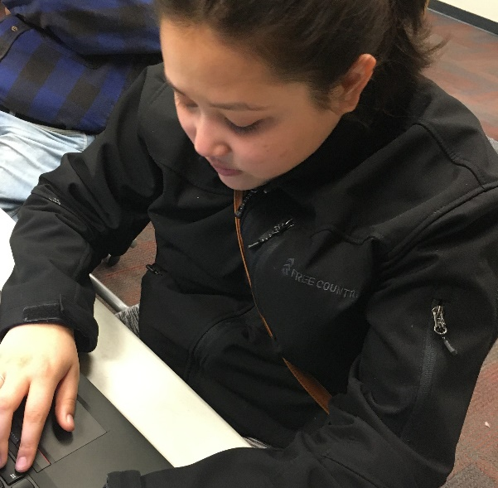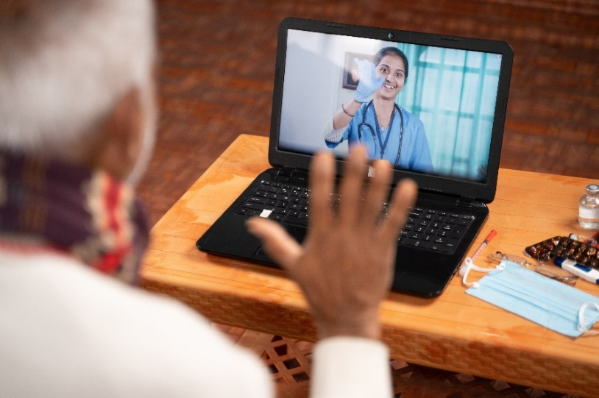

**Tech for Connectivity Program**

**Logo for Ecolibrium 3

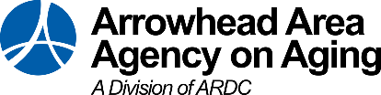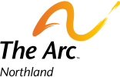**

**Offering FREE technology devices, internet, phone subscriptions, and/or training to help people connect to telehealth or other remote services!**

**Eligibility.** Participants must:

* Be receiving or eligible for Medicaid, waivers, or other Home and Community-Based Services (HCBS)
* Have a disability
* Live in northern Minnesota in an integrated community setting
* Use the technology to connect to telehealth or other eligible remote services which may include: accessing health information online, connecting remotely with PCAs or social workers, remote safety monitoring, or participating remotely in health and wellness classes.

**Lighthouse will determine eligibility and offer services on**

**first-come, first served basis. Program ends March 2024.**

**Services can be in home, in clinic or remote.**

If this program is not a fit, ask about our other technology services, including assessments, individualized training, device loans and demonstrations.

This program is funded by a grant from the Minnesota Department of Human Services.

Programming is offered in partnership with: